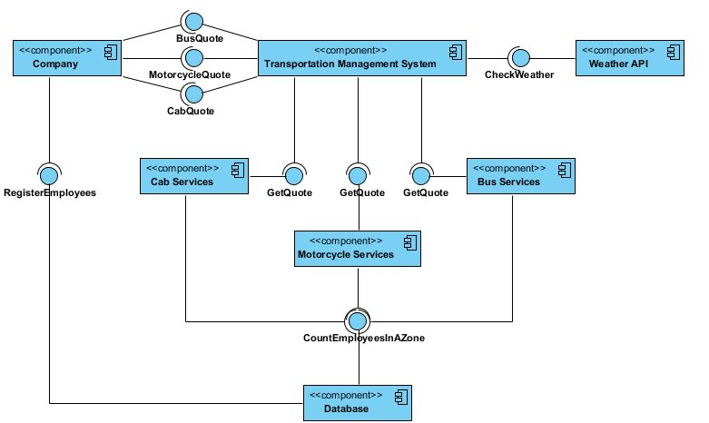

Component Diagram:

There are seven main components of the Ground Transportation System. Each has its own functionality to ultimately provide the cost of transporting a group of employees to their family destination and identifying the number of vehicles needed. The company component is responsible for generating and registering employees with the database component which will store it in a database. The company component can request a quote from the transportation management system for any of the three vehicle types (Motorcycle, Bus, Cab). The transportation management system is responsible for insuring proper weather condition for operating a vehicle. It gains this information from the weather API component which is provided from an internet source. The quote is forwarded to one of the vehicle components where they will be able to respond with a quote after obtaining the necessary information from the database component.

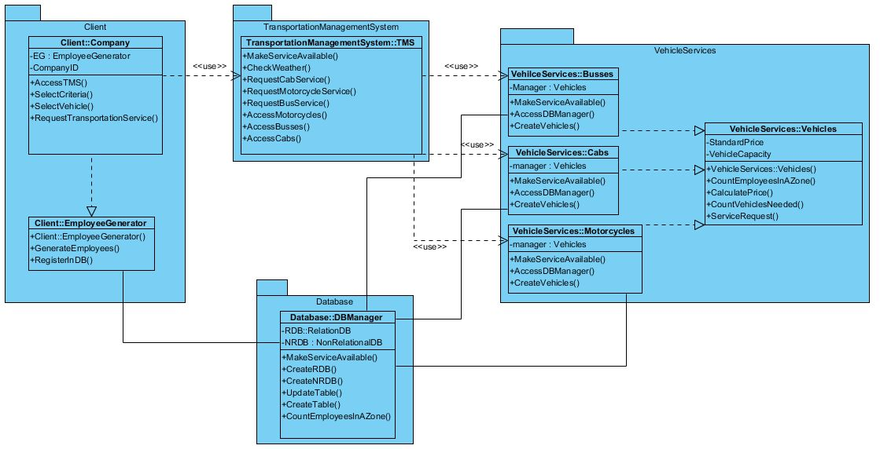

Package Diagram:

Using a simplified class diagram, the packages required by the system are represented using this package diagram. This initial design uses four packages to develop the system. The client package contains the necessary classes to create a company and generate employee data. The ability to store and update data in the database is in the database package. The transportation management system package contains the functionality to serve any company quote, the ability to contact APIs available on the internet, and forward quote requests to the vehicle services. Vehicle serves has three servers composed of the vehicle type. They were grouped together because of common functionalities between these services. It is still possible to contain each type of vehicle service in separate package if these services are to be deployed on distributed remote locations. The vehicle services package and through its main vehicle type component know how to contact the database and make the necessary calculations to provide a quote.